Docker technology

It is one implementation of container based virtualization technologies

**Virtualization Technologies:**

**Pre-Virtualization World**

**Problems:**

Huge Cost

Slow Deployment

Hard to Migrate

**Hypervisor-based Virtualization Hypervisor-based Virtualization**

Benefits:

Cost-efficient

Easy to sale

Limitation:

Kernal Resource Duplication

Application Probability issue

## Images

* + Images are read only templates used to create containers.
  + Images are created with the docker build command, either by us or by other docker users.
  + Images are composed of layers of other images.
  + Images are stored in a Docker registry.

## Containers

* + If an image is a class, then a container is an instance of a class - a runtime object.
  + Containers are lightweight and portable encapsulations of an environment in which to run applications.
  + Containers are created from images. Inside a container, it has all the binaries and dependencies needed to run the application.

## Registries and Repositories

* + A registry is where we store our images.
  + You can host your own registry, or you can use Docker’s public registry which is called DockerHub.
  + Inside a registry, images are stored in repositories.
  + Docker repository is a collection of different docker images with the same name, that have different tags, each tag usually represents a different version of the image.

**Why Using Official Images**

* + **Clear Documentation**
  + **Dedicated Team for Reviewing Image Content**
  + **Security Update in a Timely Manner**

Run our First Hello World Docker Container

#### Deep Dive into Docker Containers

* + - **running containers in detached mode**
    - **docker ps command**
    - **docker container name**
    - **docker inspect command**

|  |  |  |
| --- | --- | --- |
|  | **Run Container in Foreground** | **Run Container in Background** |
| *Description* | Docker run starts the process in the container and attaches the console to the process’s standard input, output, and standard error. | Containers started in detached mode and exit when the root process used to run the container exits. |
| *How to specify?* | default mode | -d option |
| *Can the console be used for other commands after the container is started up?* | No | Yes |

**Docker Port Mapping and**

**Docker Logs**

Docker Image Layers

## Image Layer

Image Layers

### Build Docker Images

Approach 1: committing changes made in a container

## Ways to Build a Docker Image

* + Commit changes made in a Docker container.
  + Write a Dockerfile.

## Steps

1. Spin up a container from a base image.
2. Install Git package in the container.
3. Commit changes made in the container.

## Docker commit

* + Docker commit command would save the changes we made to the Docker container’s file system to a new image.

*docker commit container_ID repository_name:tag*

Build Docker Images

Approach 2: Writing a Dockerfile

## Dockerfile and Instructions

* + A Dockerfile is a text document that contains all the instructions users provide to assemble an image.
  + Each instruction will create a new image layer to the image.
  + Instructions specify what to do when building the image.

## Docker Build Context

* + Docker build command takes the path to the build context as an argument.
  + When build starts, docker client would pack all the files in the build context into a tarball then transfer the tarball file to the daemon.
  + By default, docker would search for the Dockerfile in the build context path.

**Dockerfile In Depth**

## Steps

1. Spin up a container from a base image.
2. Install Git package in the container.
3. Commit changes made in the container.

Chain RUN Instructions

* + Each RUN command will execute the command on the top writable layer of the container, then commit the container as a new image.
  + The new image is used for the next step in the Dockerfile. So each RUN instruction will create a new image layer.
  + It is recommended to chain the RUN instructions in the Dockerfile to reduce the number of image layers it creates.

Sort Multi-line Arguments Alphanumerically

* + This will help you avoid duplication of packages and make the list much easier to update.

CMD Instructions

* + CMD instruction specifies what command you want to run when the container starts up.
  + If we don't specify CMD instruction in the Dockerfile, Docker will use the default command defined in the base image.
  + The CMD instruction doesn’t run when building the image, it only runs when the container starts up.
  + You can specify the command in either exec form which is preferred or in shell form.

Docker Cache

* + Each time Docker executes an instruction it builds a new image layer.
  + The next time, if the instruction doesn't change, Docker will simply reuse the existing layer.

Docker Cache

* + Each time Docker executes an instruction it builds a new image layer.
  + The next time, if the instruction doesn't change, Docker will simply reuse the existing layer.

## Dockerfile with Aggressive Caching

FROM ubuntu:14.04 RUN apt-get update RUN apt-get install -y git

reusing cache

reusing cache

curl

## Cache Busting

FROM ubuntu:14.04

RUN apt-get update && apt-get install -y \ git \

curl

## Cache Busting

* + You can also achieve cache-busting by specifying a package version. This is known as version pinning.

RUN apt-get update && apt-get install -y \ package-bar \

package-baz \ package-foo=1.3.*

Containerize a Hello World Web Application

Text Direction: Dockerize a Hello World Web Application

**Check out source code:**

git clone -b v0.1 https://github.com/jleetutorial/dockerapp.git

Docker Container Links

Docker Container Links

**Dockerapp Redis**

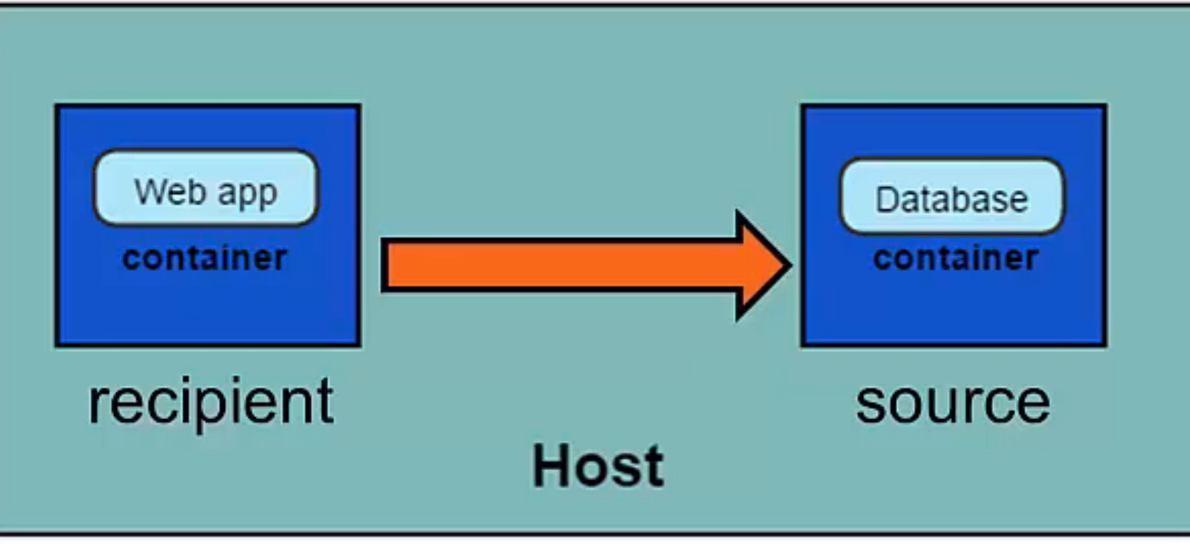

How container links

work behind the scenes?

## Benefits of Docker Container Links

* + The main use for docker container links is when we build an application with a microservice architecture, we are able to run many independent components in different containers.
  + Docker creates a secure tunnel between the containers that doesn’t need to expose any ports externally on the container.

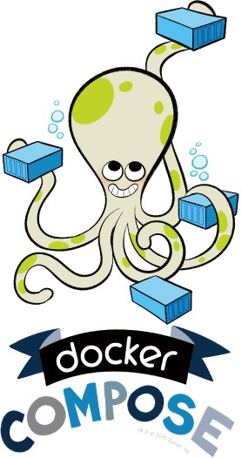

**Automate the Docker Workflow with Docker Compose**

**Deep Dive into**

**Docker Compose Workflow**

## Why Docker Compose?

Manual linking containers and configuring services become impractical when the number of containers grows.

## Docker Compose

* + Docker compose is a very handy tool to quickly get docker environment up and running.
  + Docker compose uses yaml files to store the configuration of all the containers, which removes the burden to maintain our scripts for docker orchestration.

Docker Compose Commands

* + **docker compose up starts up all the containers.**
  + **docker compose ps checks the status of the containers managed by docker compose.**
  + **docker compose logs outputs colored and aggregated logs for the compose-managed containers.**
  + **docker compose logs with dash f option outputs appended log when the log grows.**
  + **docker compose logs with the container name in the end outputs the logs of a specific container.**
  + **docker compose stop stops all the running containers without removing them.**
  + **docker compose rm removes all the containers.**
  + **docker compose build rebuilds all the images.**

**Introduction to Docker Networking**

**Docker Network Types**

* + - Closed Network / None Network
    - Bridge Network
    - Host Network
    - Overlay Network

**None Network**

## None Network

Isolated Isolated Isolated



## None Network

* + Provides the maximum level of network protection.
  + Not a good choice if network or Internet connection is required.
  + Suites well where the container require the maximum level of network security and network access is not necessary.

**Bridge Network**

## Bridge Network

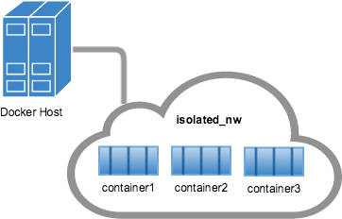

**Bridge Network**



**Container Private Network Interface**



**Container Private Network Interface**

Container B

Bridge (docker0)



Host

Internet

## Host and Overlay Network

**Host Network**

* + The least protected network model, it adds a container on the host's network stack.
  + Containers deployed on the host stack have full access to the host's interface.
  + This kind of containers are usually called open containers.

## Host Network

* + Minimum network security level.
  + No isolation on this type of open containers, thus leave the container widely unprotected.
  + Containers running in the host network stack should see a higher level of performance than those traversing the docker0 bridge and iptables port mappings.

Define Container Networks with Docker Compose

Write and Run Unit Tests in Docker Containers

## Unit Tests in Containers

* Unit tests should test some basic functionality of our docker app code, with no reliance on external services.
* Unit tests should run as quickly as possible so that developers can iterate much faster without being blocked by waiting for the tests results.
* Docker containers can spin up in seconds and can create a clean and isolated environment which is great tool to run unit tests with.

Incorporating Unit Tests into Docker Images

Pros:

* + A single image is used through development, testing and production, which greatly ensures the reliability of our tests.

Cons:

* + It increases the size of the image.

Fit Docker Technology into Continuous Integration(CI) Process

What is Continuous Integration?

* Continuous integration is a software engineering practice in which isolated changes are immediately tested and reported when they are added to a larger code base.
* The goal of Continuous integration is to provide rapid feedback so that if a defect is introduced into the code base, it can be identified and corrected as soon as possible.

##### A Typical CI Pipeline without Docker

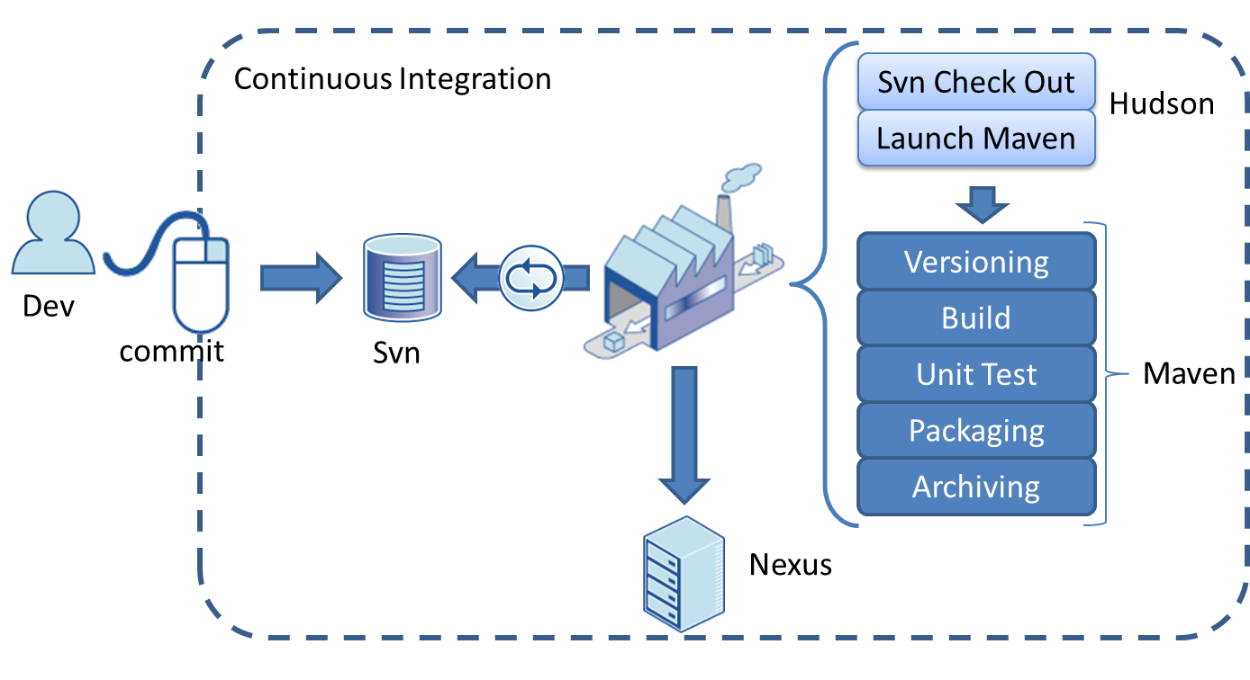

**Continuous Integration Server**

**Version control system**

**Production Servers**

**Check out source code**

CI process with Docker technologies involved

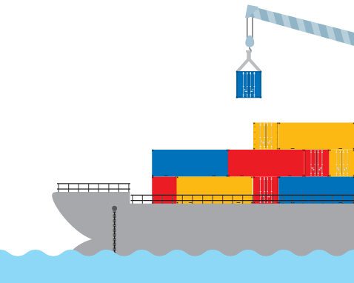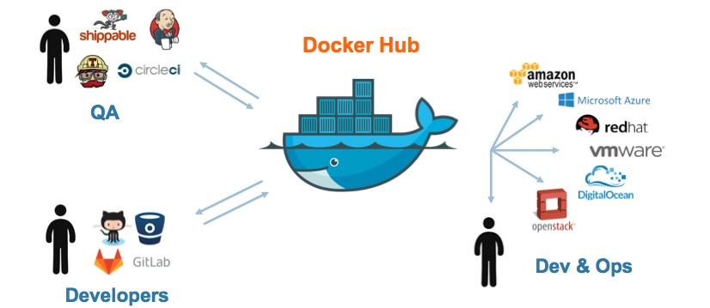

**Pull docker images**

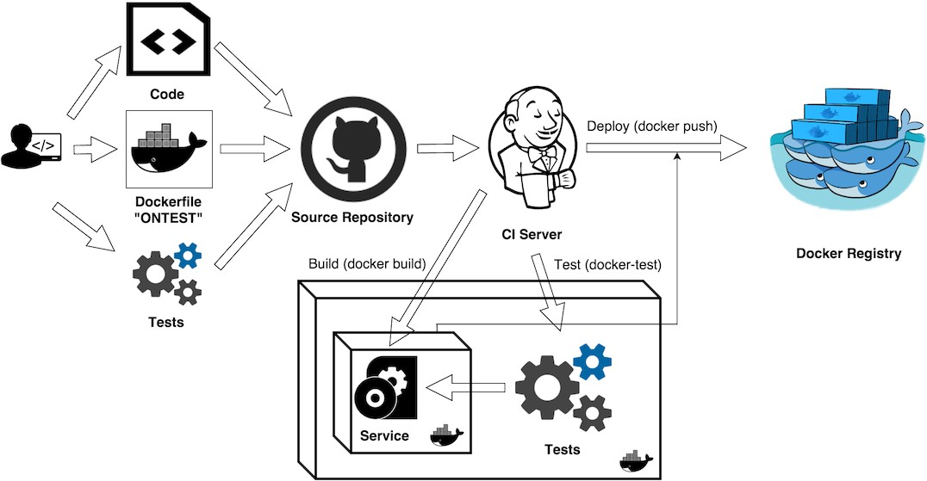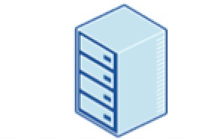

**Staging / Production**



Our Continuous Integration Pipeline

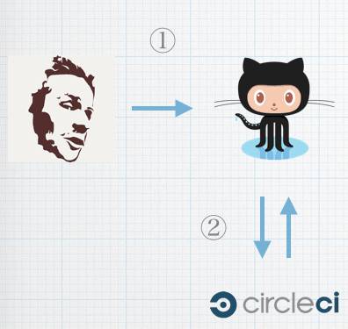**Github**

**Central Repository for Version Control**

**Hosted Continuous Integration Server**



Text Direction: Introduction to Continuous Integration

**URL of the Github account to fork:**

https://github.com/jleetutorial/dockerapp

**Checking for existing SSH keys:**

https://help.github.com/articles/checking-for-existing-ssh-keys/

**Generating a new SSH key and adding it to the ssh-agent:** https://help.github.com/articles/generating-a-new-ssh-key-and-adding-it-to- the-ssh-agent

**Adding a new SSH key to your GitHub account:** https://help.github.com/articles/adding-a-new-ssh-key-to-your-github- account/

Link Circle CI with GitHub Account

to build a Continuous Integration pipeline

###### Set up SSH keys for Github Account

* + SSH keys are a way to identify trusted computers without involving password.
  + Generate a SSH key pair and save the private SSH key in your local box and add the public key to your GitHub account.
  + Then you can directly push your changes to github repository without typing password.

**How to check if SSH public key files are available on your local box?**

The SSH public key file usually sits under ***~/.ssh/*** directory and ends with

***.pub*** extension.

Link Circle CI with GitHub Account

Complete CI Workflow

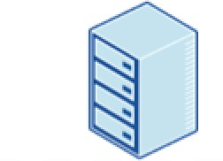**Github**

**Central Repository for Version Control**

**Staging / Production**

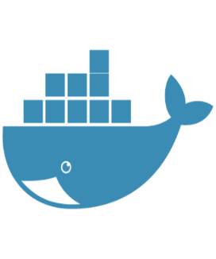

Pull Docker image

Publish Docker image

**Docker Hub**

**Hosted Continuous Integration Server**

**Tag the Docker Images with Two Tags**

* 1. commit hash of the source code
  2. latest

Introduction to Running Docker in Production

###### Opinions about Running Docker in Production

* One one hand, many docker pioneers are confident that a distributed web app can be deployed at scale using Docker and have incorporated Docker into their production environment.
* On the other hand, there are still some people who are reluctant to use Docker in production as they think docker workflow is too complex or unstable for real life use cases.

Is Docker Production

Ready Now?

###### Concerns about Running Docker in Production

* There are still some missing pieces about Docker around data persistence, networking, security and identity management.
* The ecosystem of supporting Dockerized applications in production such as tools for monitoring and logging are still not fully ready yet.

Companies which already run Docker in Production

**Why Running Docker Containers inside VMs?**

* To address security concerns.
* Hardware level isolation.

They all run containers inside VMs

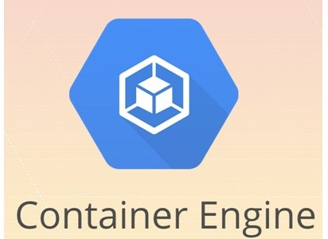



Docker Machine



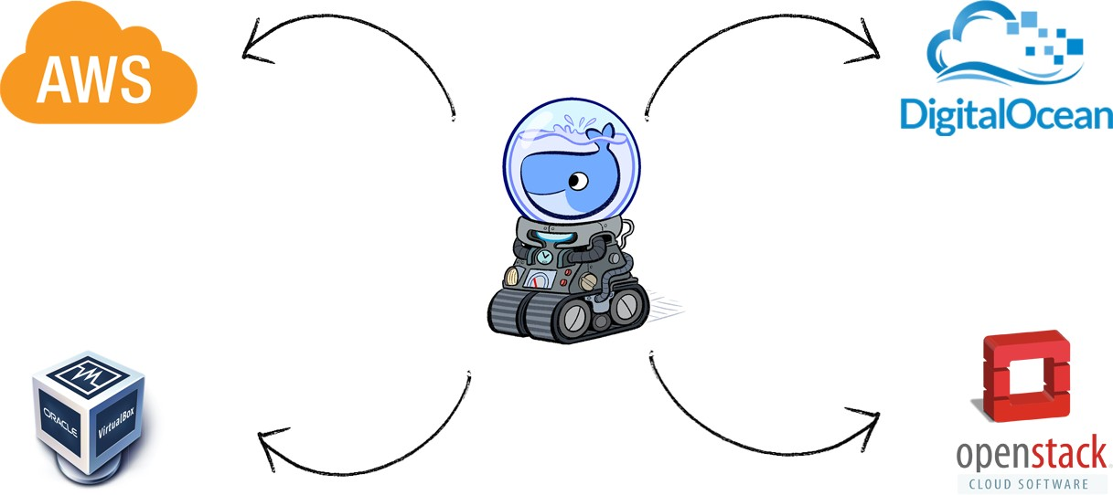





**Register Digital Ocean Account to Deploy Containerized Applications**

**Deploy Docker App to the Cloud with**

**Docker Machine**

Text Direction: Deploy Docker App to the Cloud with Docker Machine

**Docker Machine Create command**

docker-machine create --driver digitalocean --digitalocean-access-token

<xxxxx> docker-app-machine

**Introduction to Docker Swarm**

**and**

**Set up Swarm cluster**

## How Swarm cluster works

* To deploy your application to a swarm, you submit your service to a manager node.
* The manager node dispatches units of work called tasks to worker nodes.
* Manager nodes also perform the orchestration and cluster management functions required to maintain the desired state of the swarm.
* Worker nodes receive and execute tasks dispatched from manager nodes.
* An agent runs on each worker node and reports on the tasks assigned to it. The worker node notifies the manager node of the current state of its assigned tasks so that the manager can maintain the desired state of each worker.

**Deploy Docker App Services to the Cloud via Docker Swarm**



**Docker Swarm**

## Docker Services

* The services can be defined in our Docker compose file.
* The service definition includes which Docker images to run, the port mapping and dependency between services.

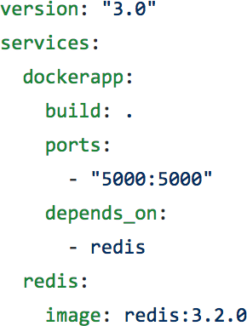

## Docker Services

* 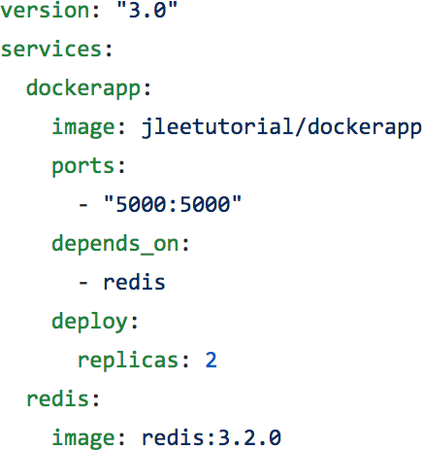When we are deploying services in the swarm mode, we can also set another important configuration, which is the deploy key and it is only available on Compose file formats version 3.x and up.
* The deploy key and its sub-options can be used to load balance and optimize performance for each service.

## Deploy Key in Docker Compose file

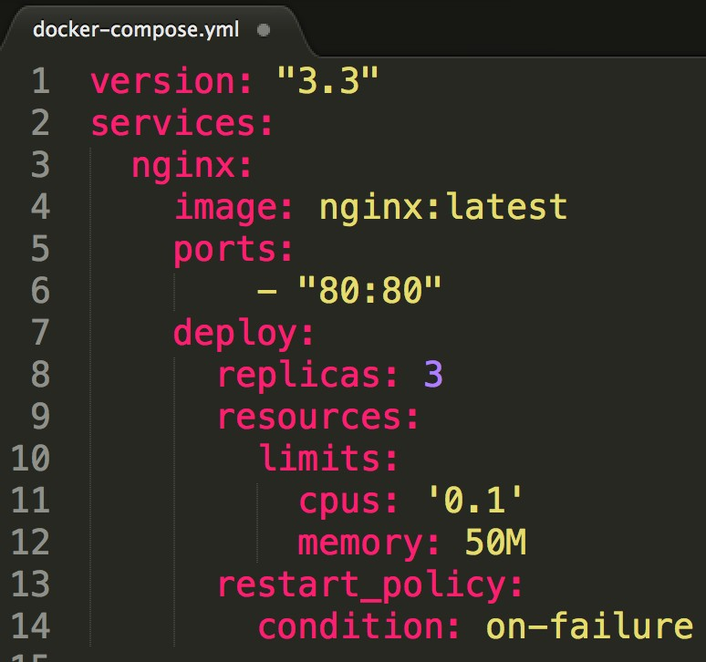

Replicas

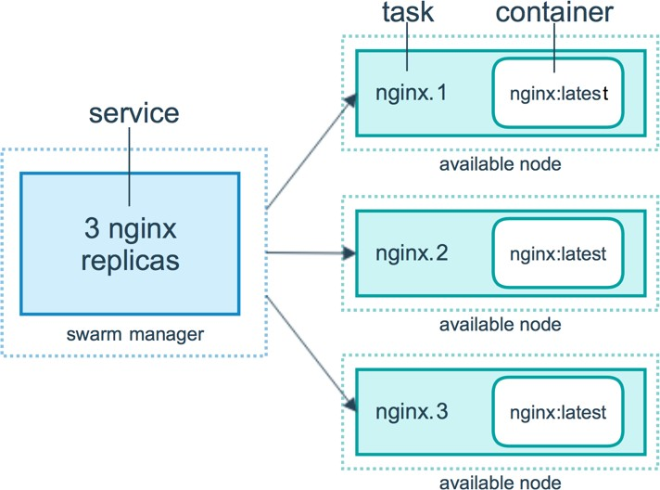

## Replicas



**80**

**80**

**80**

Replicas

* + We can connect to the nginx service through a node which does NOT have



**80** nginx replicas.

* *Ingress load balancing*

**80** • All nodes listen for connections

to published service ports.

* When that service is called by external systems, the receiving

**80** node will accept the traffic and internally load balance it using an internal DNS service that

Docker maintains.

**80**

## Docker Stack

* A docker stack is a group of interrelated services that share dependencies, and can be orchestrated and scaled together.
* You can image that a stack is a live collection of all the services defined in your docker compose file.
* Create a stack from your docker compose file:

– docker stack deploy

* In the Swarm mode,
* Docker compose files can be used for service definitions.
* Docker compose commands can’t be reused. Docker compose commands can only schedule the containers to a single node.
* We have to use docker stack command. You can think of docker stack as the docker compose in the swarm mode.

How to update our services in Production?

## Provision a Swarm Cluster

* Step 1: Deploy two VMs, one will be used for the Swam manager node, and the other one will be used as a worker node.
* Step 2: Appoint the first VM as Swarm manager node and initialize a Swarm cluster.

– docker swarm init

* Step 3: Let the second VM join the Swarm cluster as a worker node.

– docker swarm join

## Provision a Swarm Cluster

* Step 1: Deploy two VMs, one will be used for the Swam manager node, and the other one will be used as a worker node.
* Step 2: Appoint the first VM as Swarm manager node and initialize a Swarm cluster.

– docker swarm init

* Step 3: Let the second VM join the Swarm cluster as a worker node.

– docker swarm join

## Provision a Swarm Cluster

* Step 1: Deploy two VMs, one will be used for the Swam manager node, and the other one will be used as a worker node.
* Step 2: Appoint the first VM as Swarm manager node and initialize a Swarm cluster.

– docker swarm init

* Step 3: Let the second VM join the Swarm cluster as a worker node.

– docker swarm join

## Docker Swarm commands

* docker swarm init

– Initialize a swarm. The docker engine targeted by this command becomes a manager in the newly created single-node swarm.

* docker swarm join

– Join a swarm as a Swarm node.

* docker swarm leave

– Leave the swarm.